User Testing

Table of Content

1. Sign Up and Login
2. Sign Up with empty username and password
3. log in with empty username and password
4. Sign Up with incorrect confirmation password
5. login in with invalid password
6. log in with correct credentials
7. Email Verification

2. Products

1. Sorting Product in alphabetical order
2. Add to Cart
3. Removing product from Cart
4. Clear All product from Cart

3.Checkout

1. Shipping through PayPal
2. Logging in PayPal
3. Order Confirmation

4.Logout

User Sign in

1. User sign in and log in with empty username and password

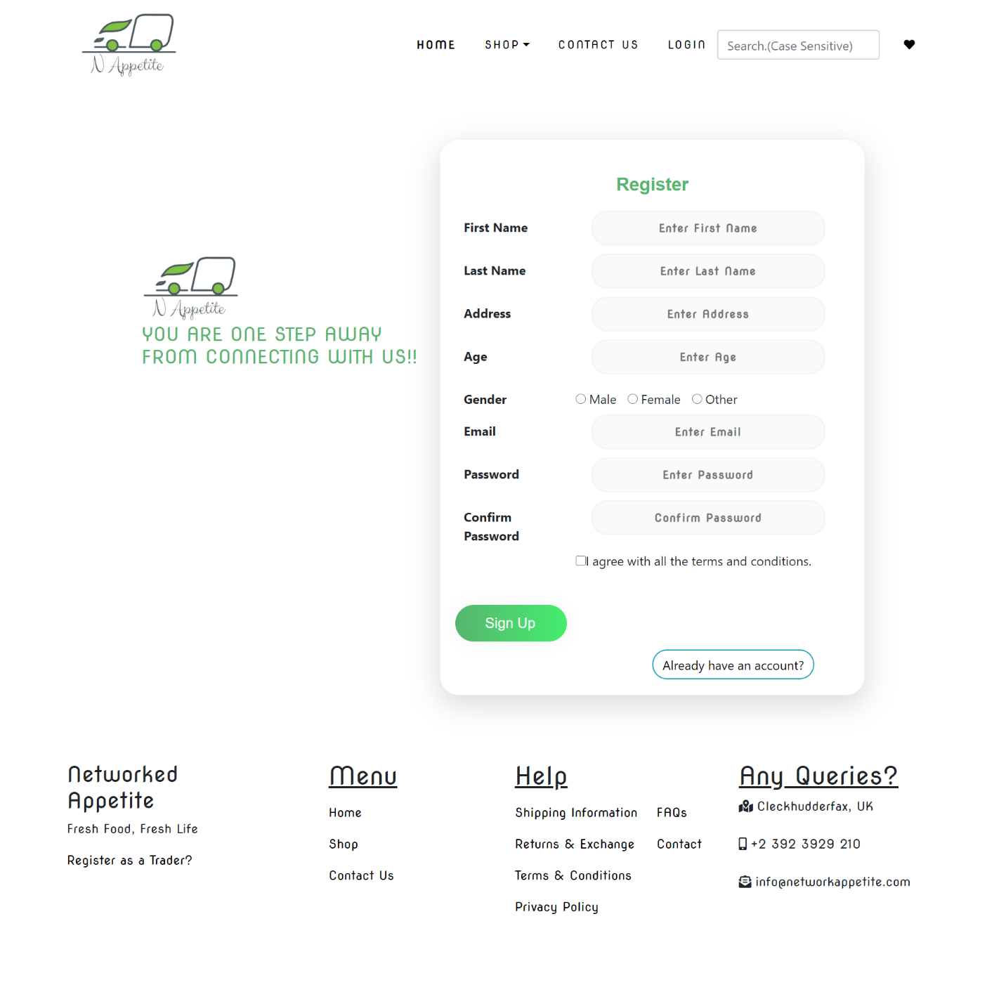

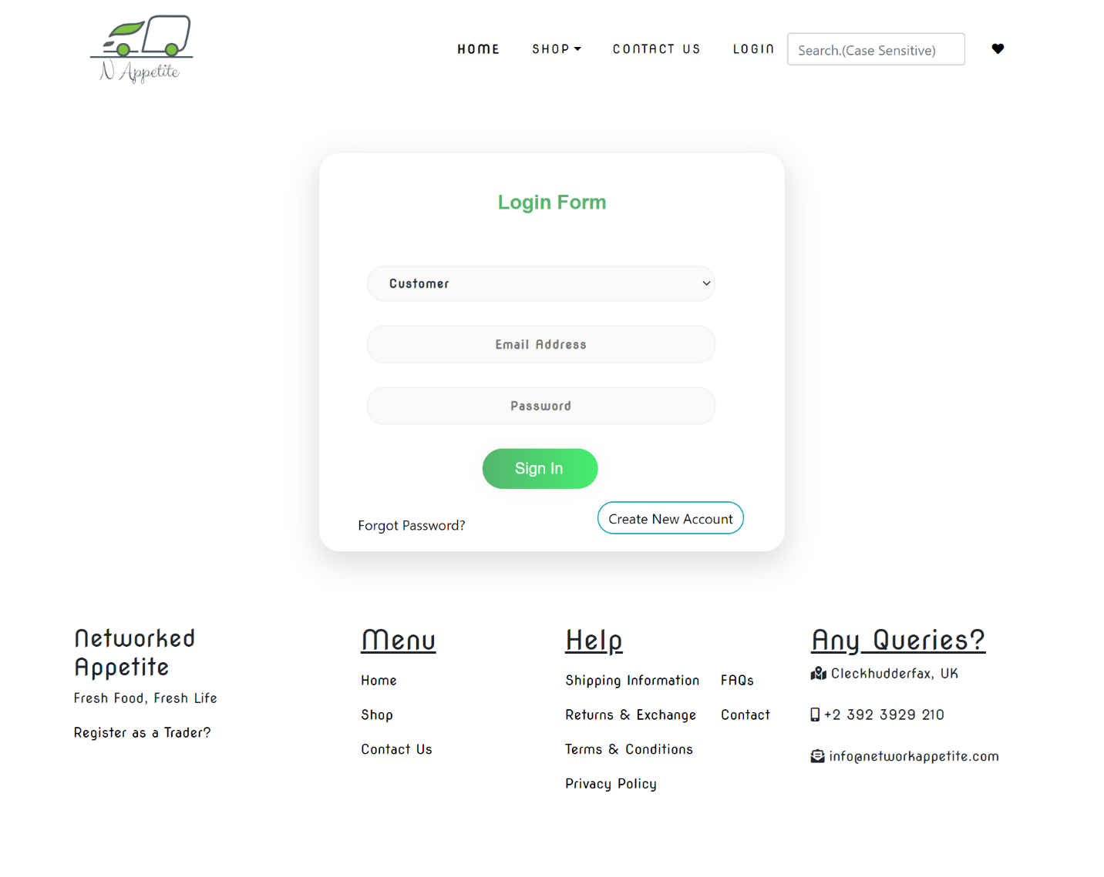

If user tries to log in with empty username and password then an error message is displayed “Invalid Login Credentials”.

1. Sign in and Login With Invalid Password

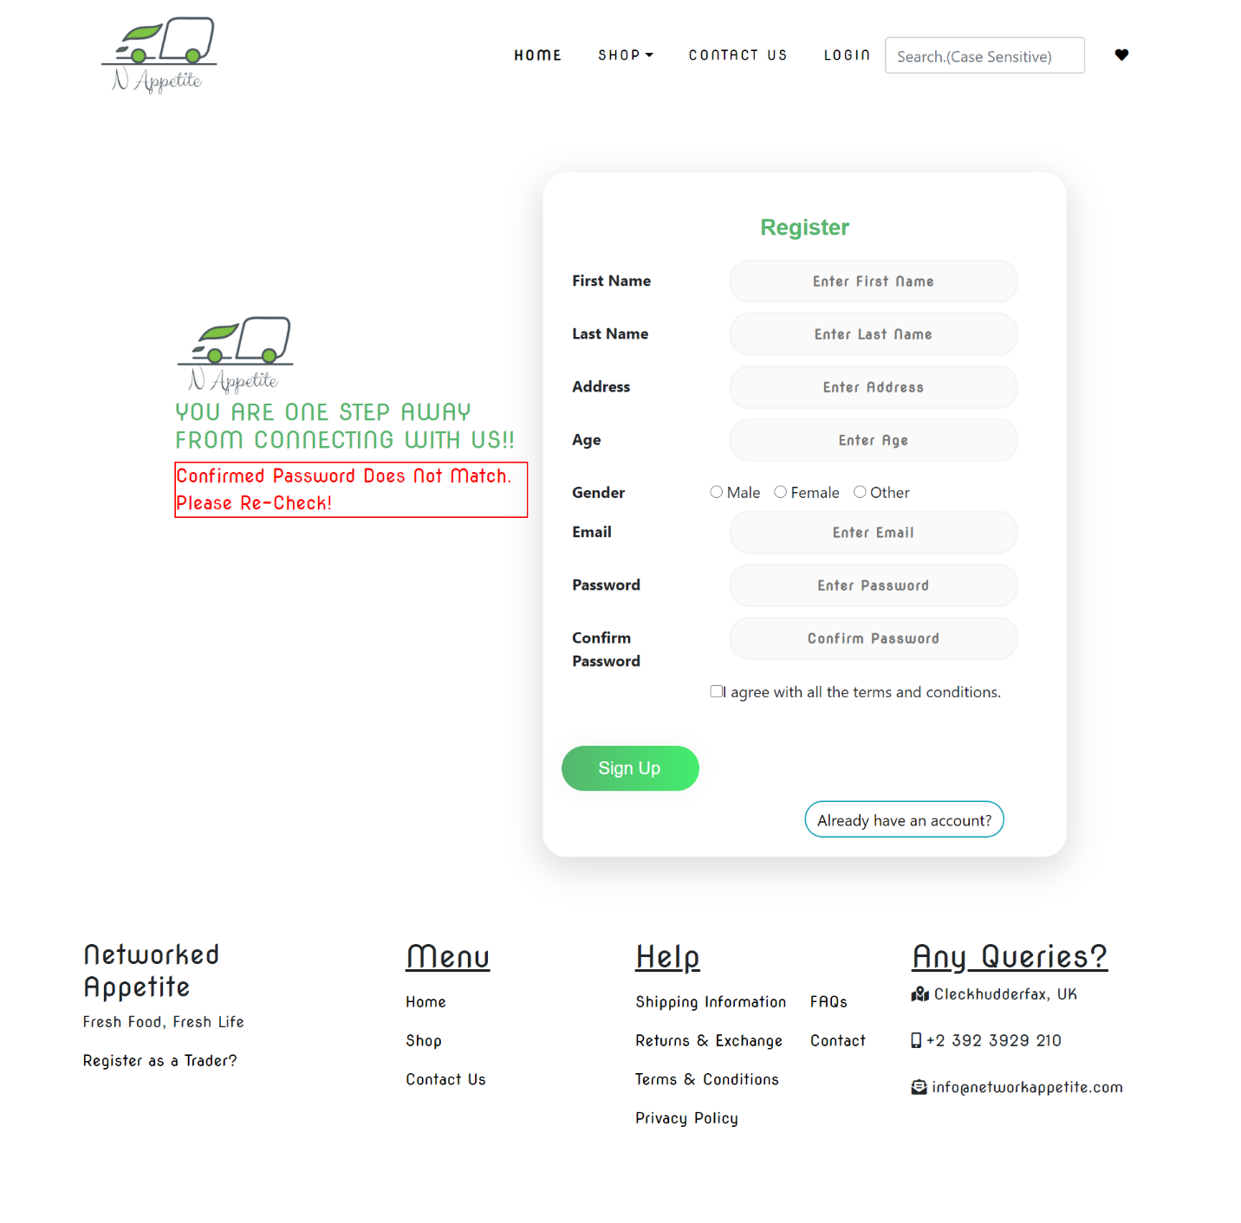

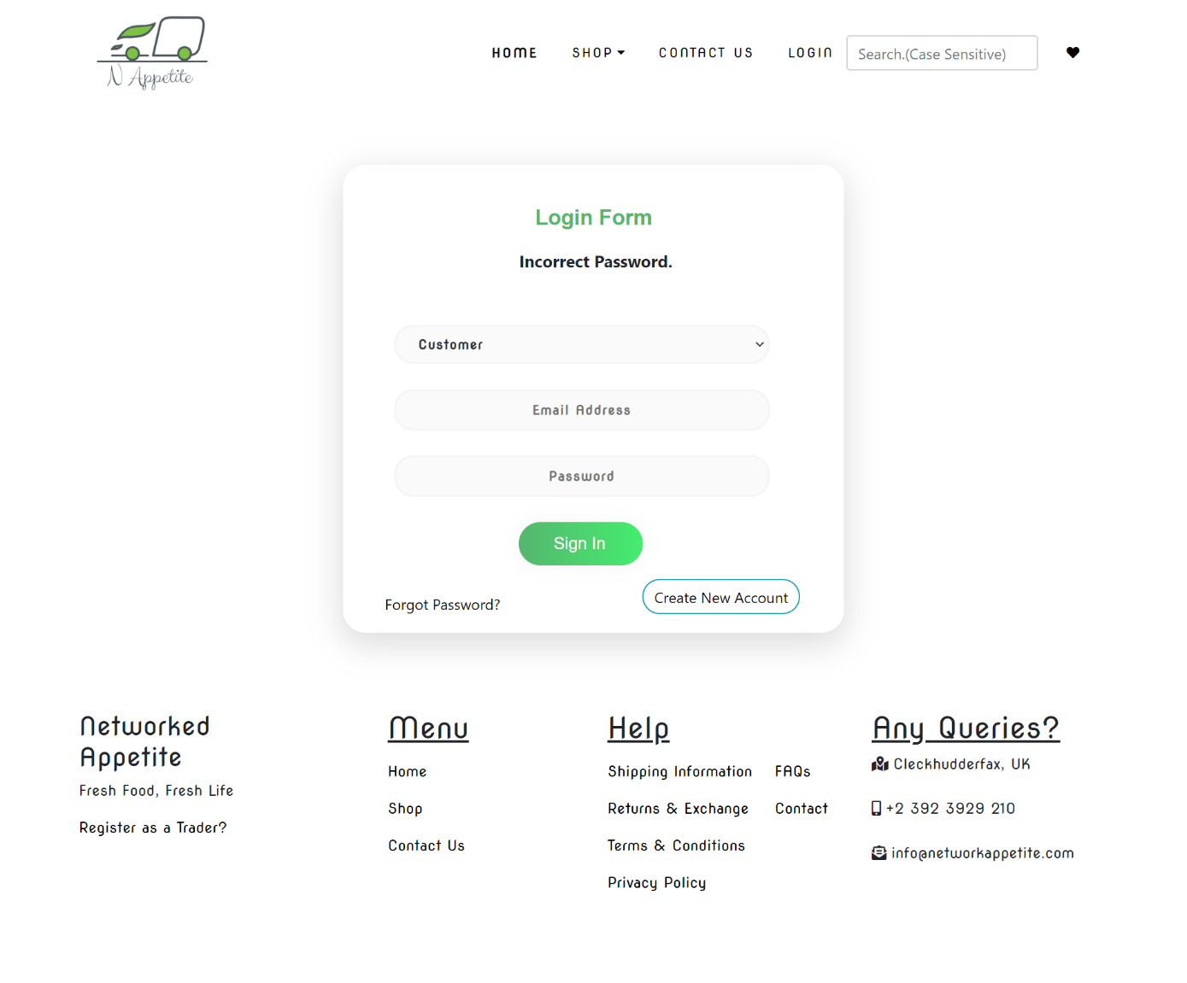

If user tries to log in with wrong password then an error message is displayed ‘Incorrect Password’

Email Verification

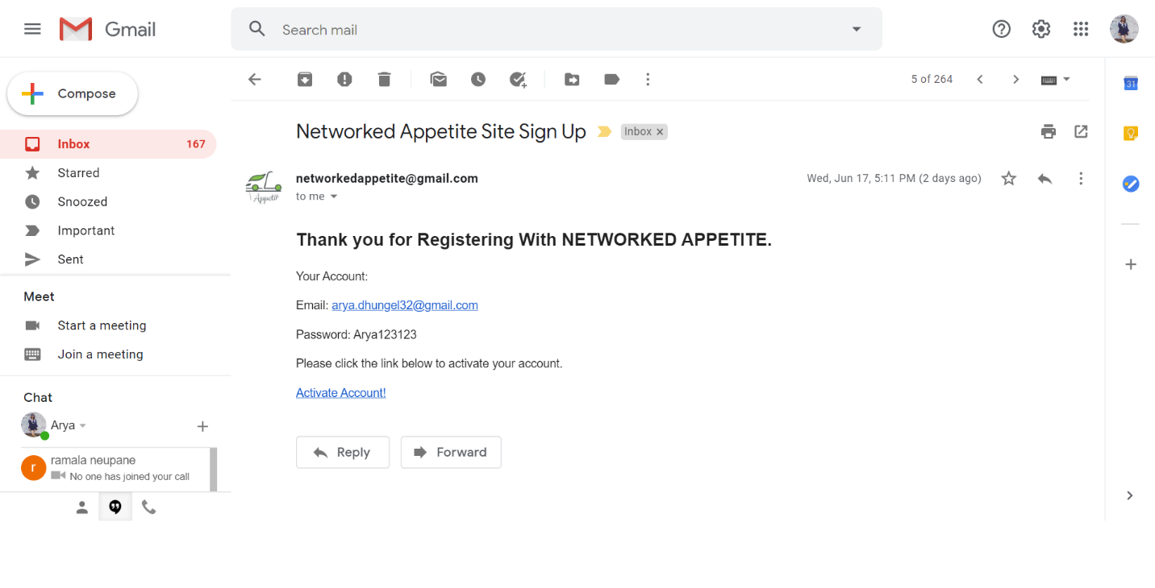

User gets email verification after they register and before they login.

1. User login with valid credentials(logged in with one of the user account)

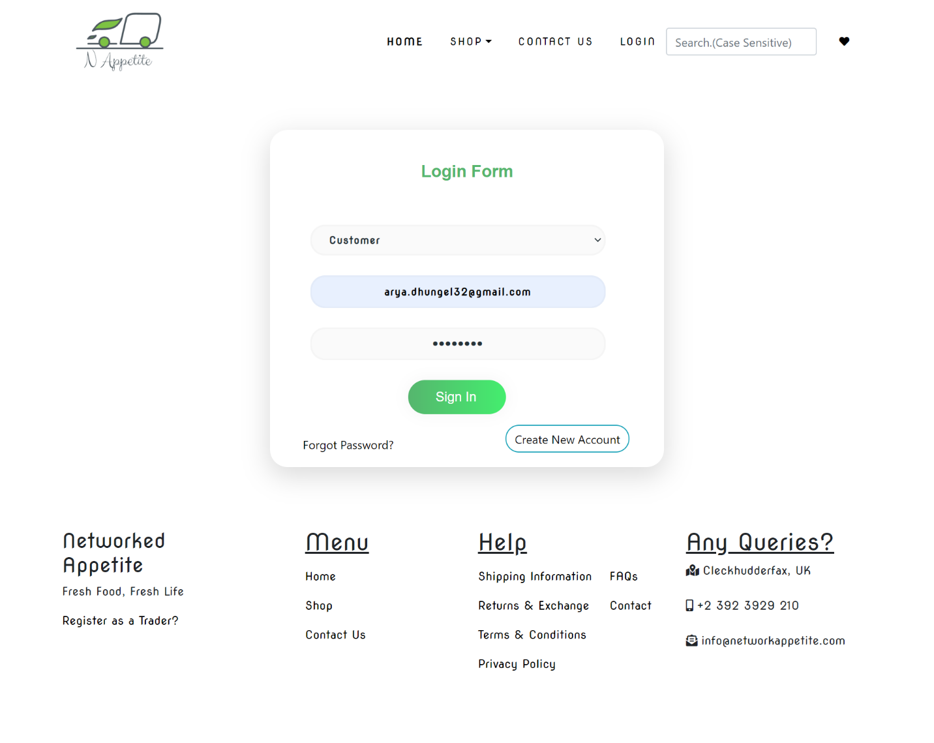

If user log in with valid credentials then user gains access to the shop.

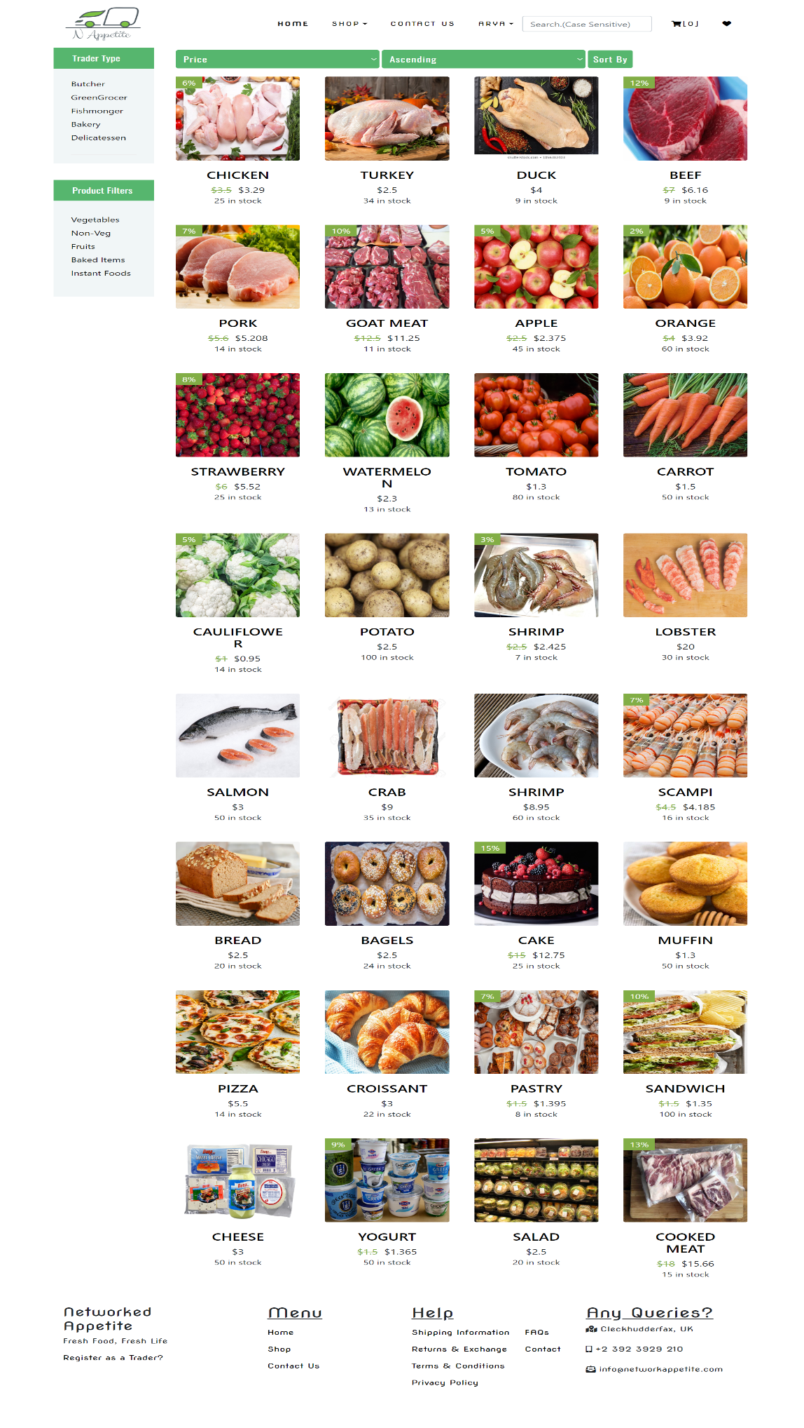

Sorting through alphabetical order -

# 

Adding Product to Cart

# 

Removing Product from cart

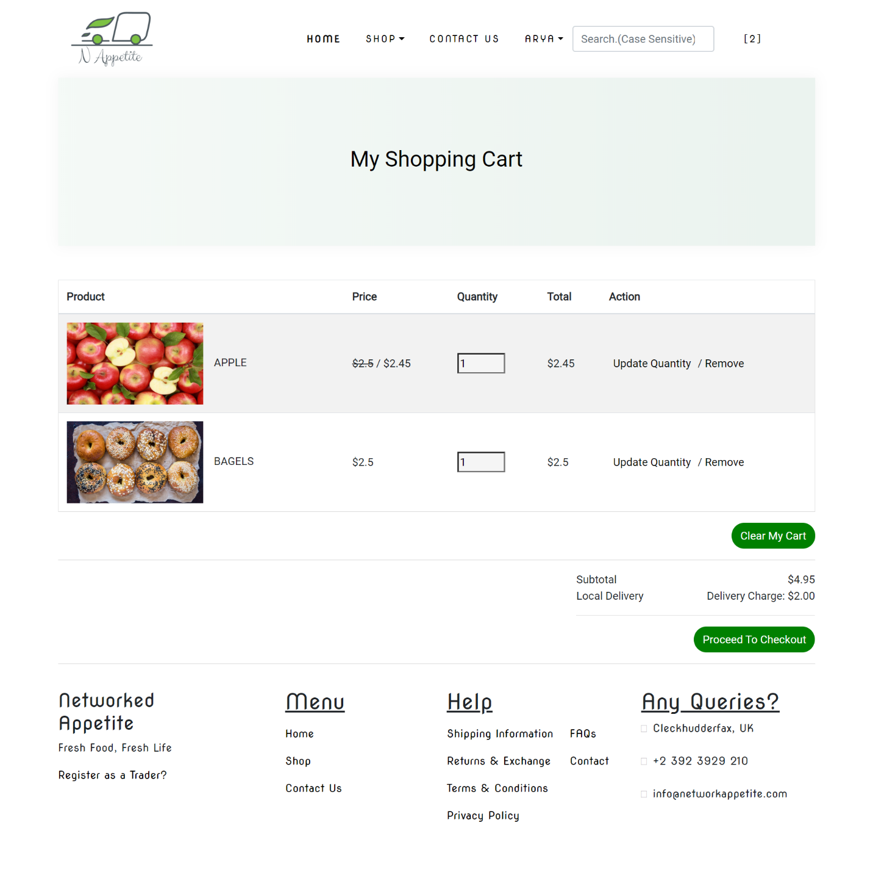

Clearing products from cart by clicking at ‘Clear All’ button

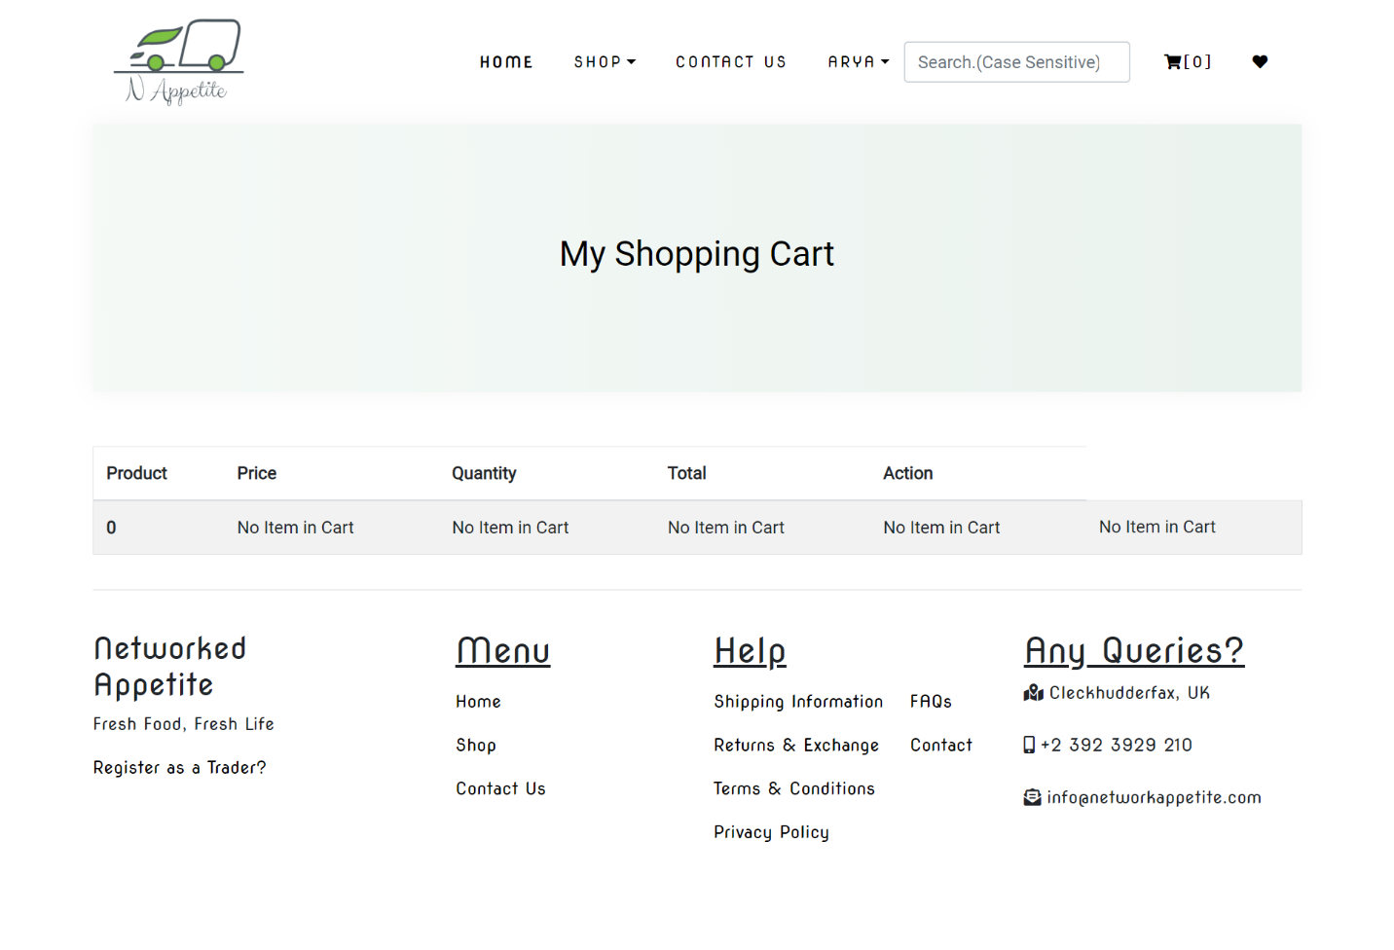

Checkout (Payment with PayPal)

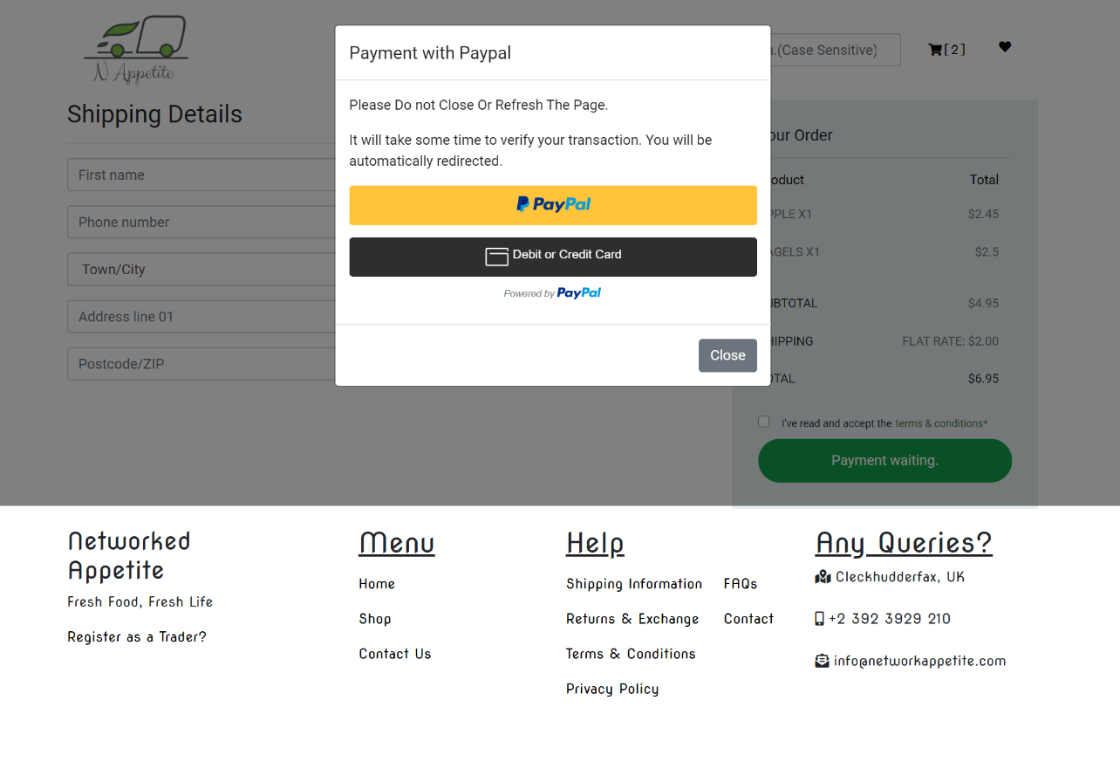

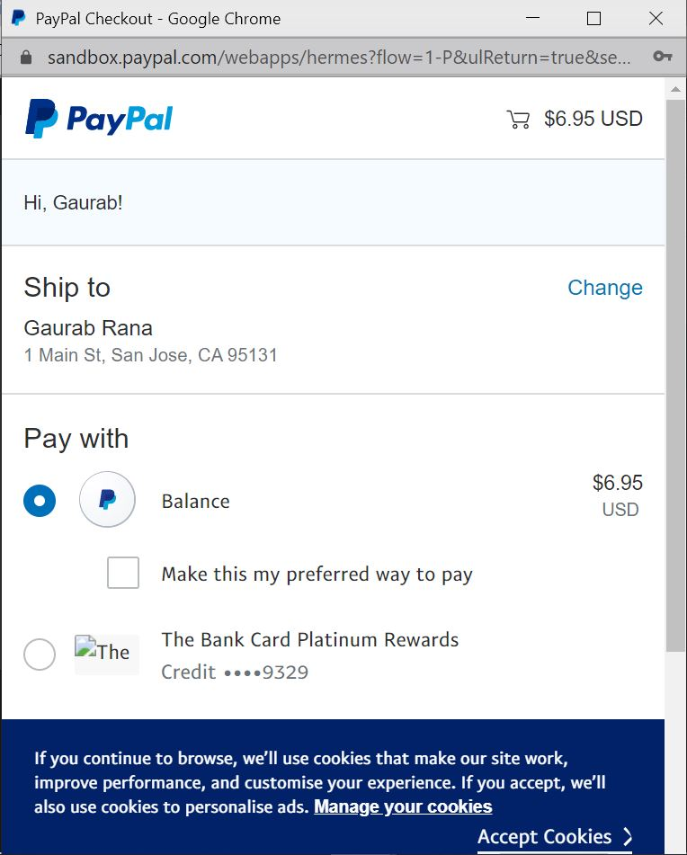

Order Confirmation

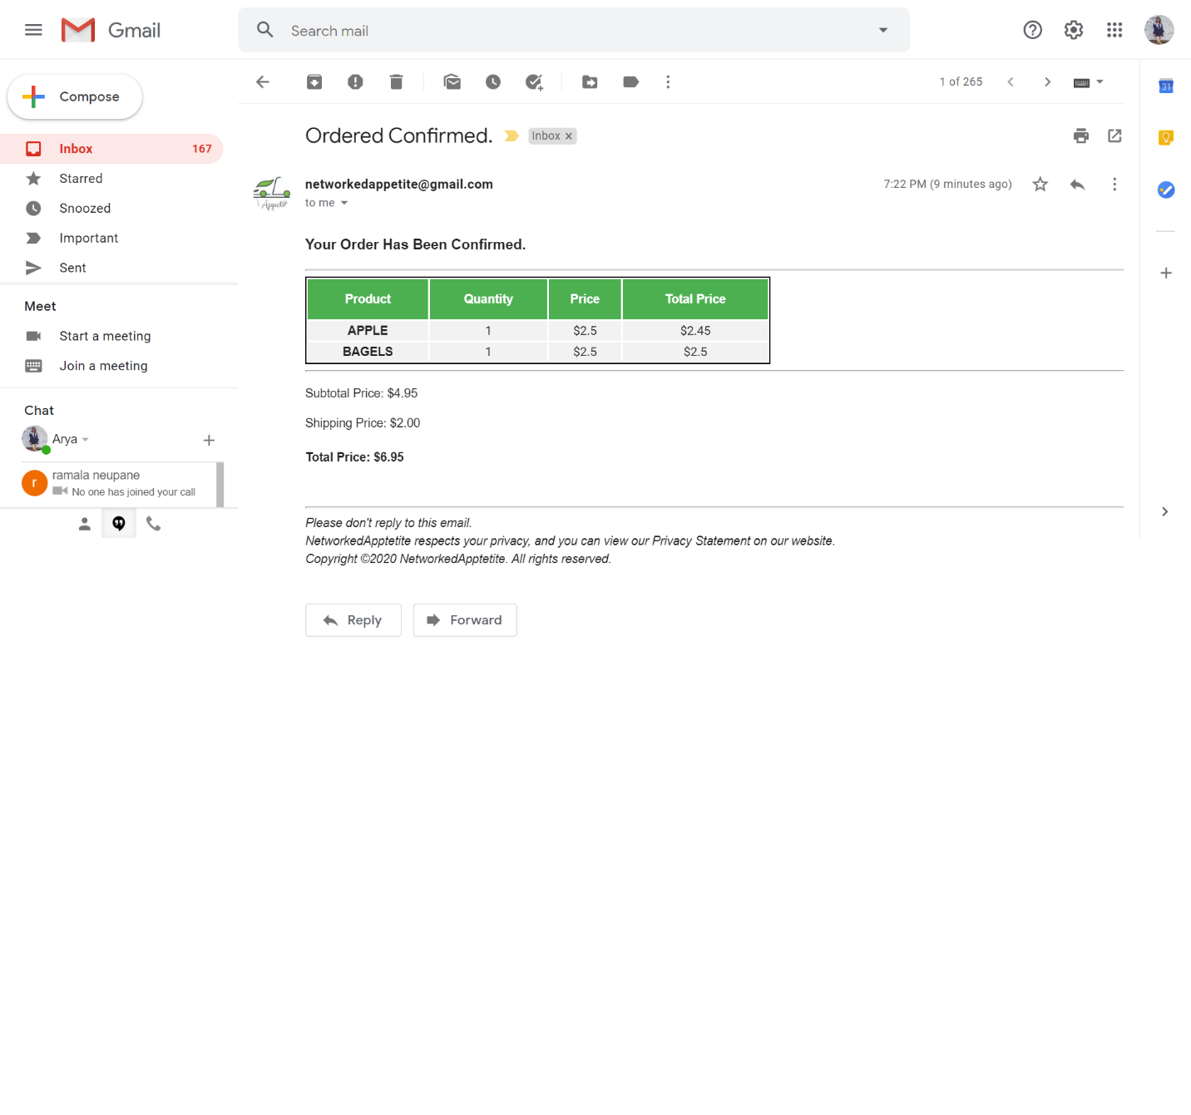

Surfing through trader type (Bakery)

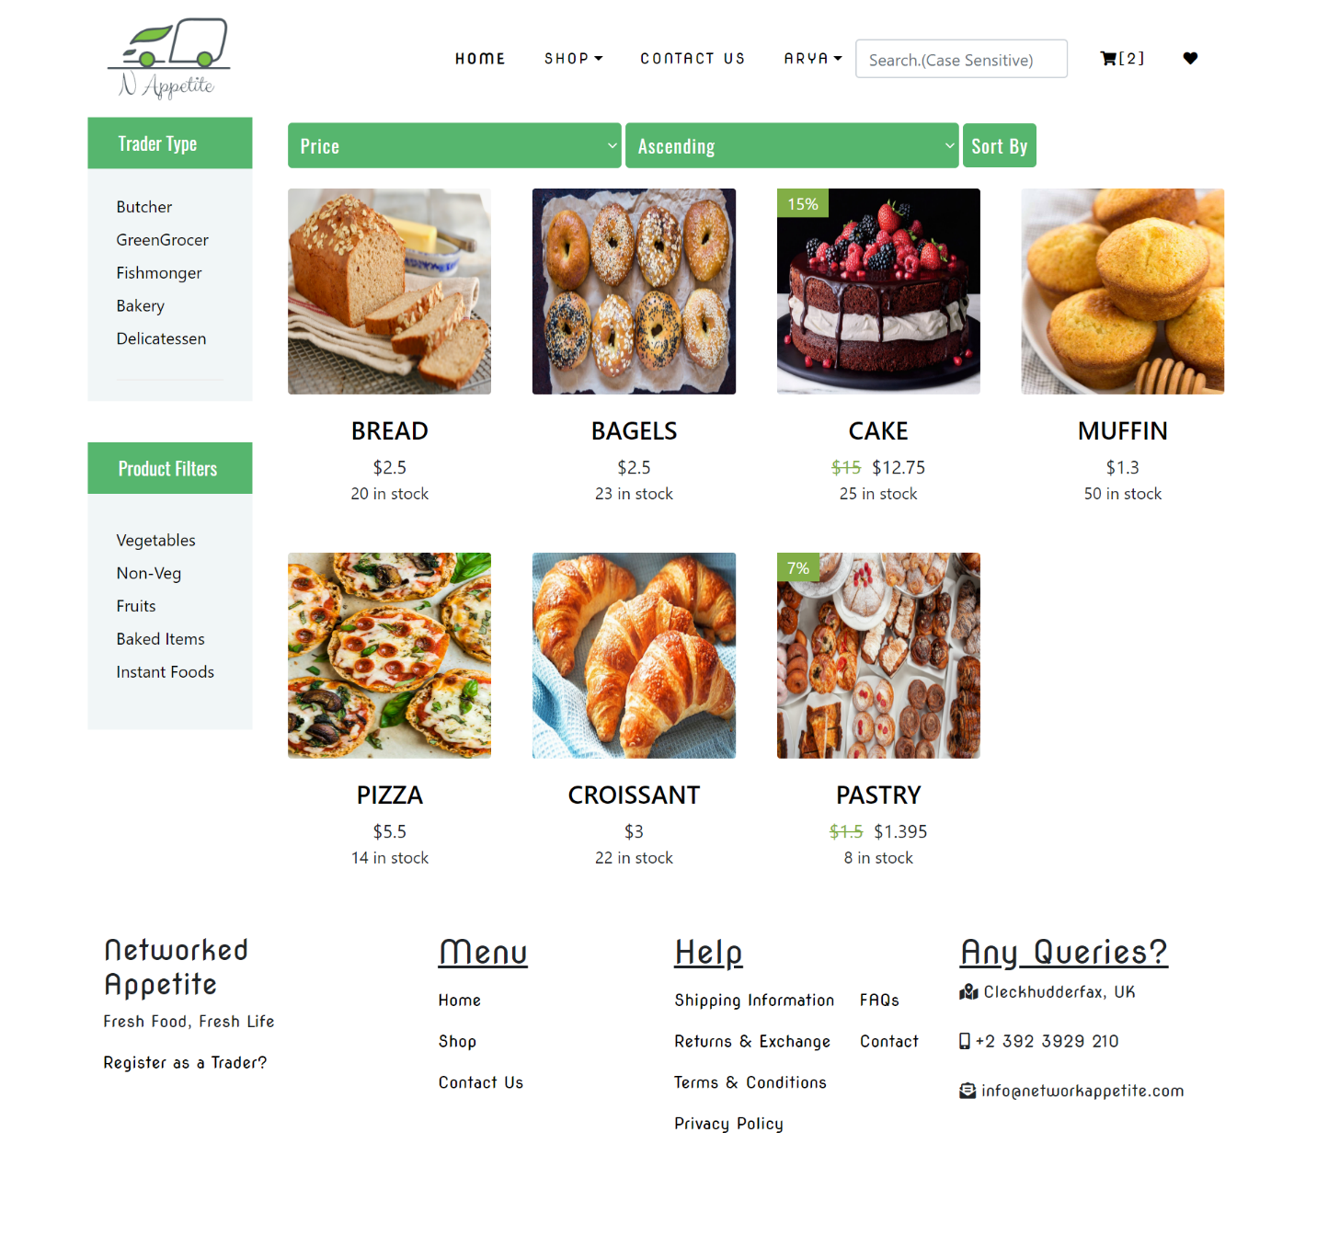

Logout

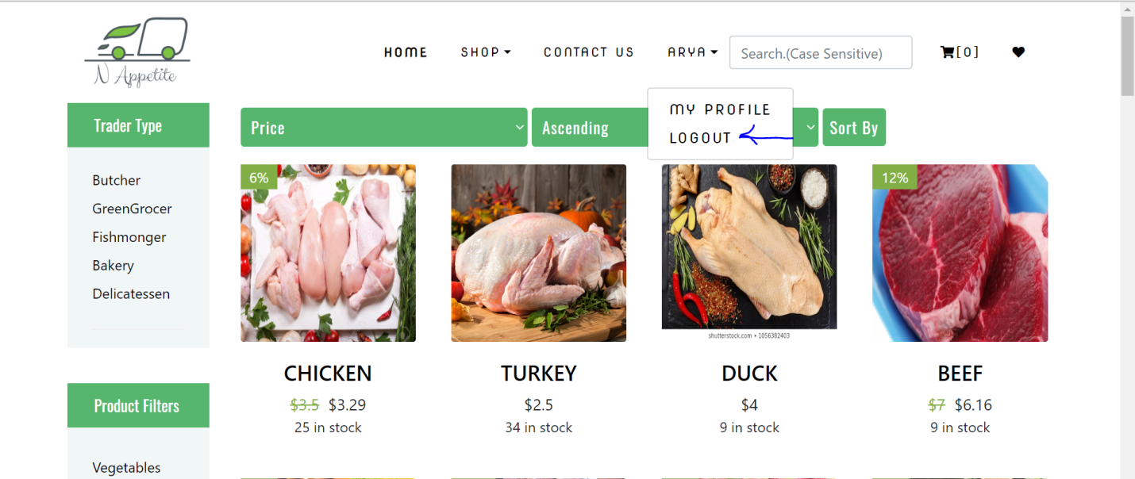

Users can logout from the page using Sign Out button at the drop-down menu by clicking at their name.